Relačné funkcie

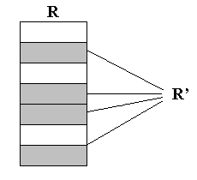
1. VÝBER

SELECT * FROM predmet
WHERE gestor = "30088"

2. PROJEKCIA
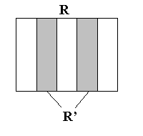
SELECT meno, priezvisko
FROM os_udaje

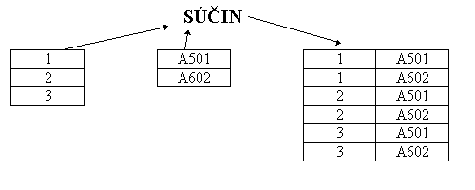
3. KARTÉZSKY SÚČIN

SELECT meno, priezvisko FROM os_udaje INTO TEMP a;
SELECT cis_predmet FROM predmet INTO TEMP b;
SELECT meno, priezvisko, cis_predmet FROM a,b

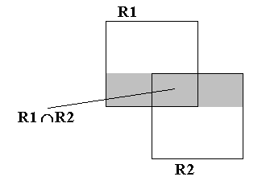
4. PRIENIK

SELECT rod_cislo FROM os_udaje
WHERE rod_cislo IN
(SELECT rod_cislo FROM student
WHERE opakovanie = "a")

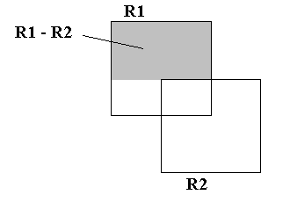
5. ROZDIEL

SELECT rod_cislo FROM os_udaje
WHERE rod_cislo NOT IN
(SELECT rod_cislo FROM student
WHERE opakovanie = "a")

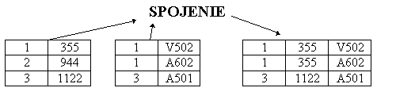
6. SPOJENIE

SELECT student.*, zap_predmety.*
FROM student, zap_predmety
WHERE student.os_cislo = zap_predmety.os_cislo

7. ZJEDNOTENIE
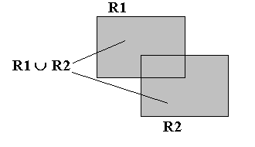
/pôvodná tabuľka os_udaje je rozdelená na 2 tabuľky os_udaje_zeny a os_udaje_muzi /
SELECT meno, priezvisko FROM os_udaje
WHERE rod_cislo[3,3] >4 INTO TEMP os_udaje_zeny;
SELECT meno, priezvisko FROM os_udaje
WHERE rod_cislo[3,3] <5 INTO TEMP os_udaje_muzi;

SELECT meno, priezvisko FROM os_udaje_zeny
UNION
SELECT meno, priezvisko FROM os_udaje_muzi

8. DELENIE
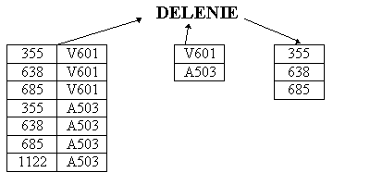
SELECT cis_predmet FROM predmet
WHERE predmet.cis_predmet = "V601" OR
predmet.cis_predmet = "A503"
INTO TEMP menovatel;

SELECT COUNT(*) pocet FROM menovatel
INTO TEMP yyy;

SELECT os_cislo FROM zap_predmety
WHERE cis_predmet IN
(SELECT cis_predmet FROM menovatel)
INTO TEMP xxx;

SELECT os_cislo, COUNT(*) pocet
FROM xxx
GROUP BY os_cislo
INTO TEMP zzz;

SELECT os_cislo FROM zzz, yyy
WHERE zzz.pocet = yyy.pocet

